**PRACTICAL 1-B:**

**Index.html:**

<html>

<head>

<title>TODO supply a title</title>

<meta charset="UTF-8">

<meta name="viewport" content="width=device-width, initial-scale=1.0">

</head>

<body>

<div>Practical 1B - Binal-Doshi</div>

<form action="MyServlet">

Enter username:<input type="text" name="uname">

<br>

Enter password:<input type="text" name="pass">

<br>

<input type="submit" value="Login">

</form>

</body>

</html>

**MyServlet Page:**

public class MyServlet extends HttpServlet {

protected void processRequest(HttpServletRequest request, HttpServletResponse response)

throws ServletException, IOException {

response.setContentType("text/html;charset=UTF-8");

try (PrintWriter out = response.getWriter()) {

/* TODO output your page here. You may use following sample code. */

out.println("<!DOCTYPE html>");

out.println("<html>");

out.println("<head>");

out.println("<title>Servlet MyServlet</title>");

out.println("</head>");

out.println("<body>");

String s1 = request.getParameter("uname");

String s2 = request.getParameter("pass");

if(s1.equals("Admin") && s2.equals("upg"))

out.println("<h1>" + "Login Successfully" + "</h1>");

else

out.println("<h1>" + "Login Failed" + "</h1>");

out.println("</body>");

out.println("</html>");

}

}Bottom of Form

**Web.xml:**

</session-config>

<welcome-file-list>

<welcome-file>index.html</welcome-file>

</welcome-file-list>

</web-app>

**OUTPUT:**

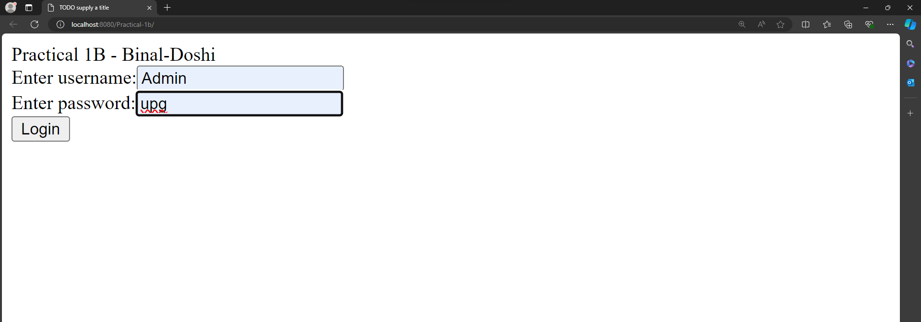

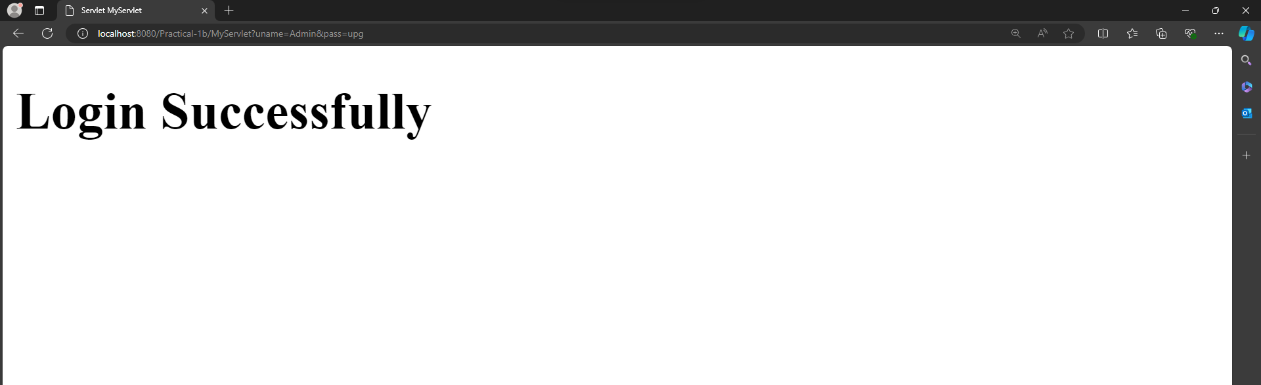

**PRACTICAL**